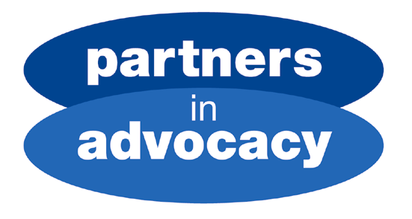

Voices for Choices

SMART TALK

May Newsletter
Hi there from Andy at Partners in Advocacy



It is now 3 months since Lorna left and I took over as the advocacy worker in East Lothian. Nobody likes change and I realise life without Lorna has been difficult for some people. However advocacy and Smart Talk carries on.

As the new guy, I would like to thank everybody for making me feel welcome. I shall try to carry on the good work of Lorna.

Smart Talk needs to let more people with a learning disability in East Lothian say how they feel and what they want. So more Smart Talk groups are being set up. They will be in:

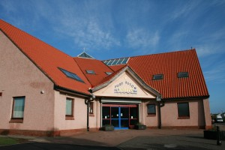
Tynebank Fisherrow Port Seton

If you use one of these centres, you are welcome to join Smart Talk and have your say on what you want out of life in East Lothian. Just look for me. I visit every 2 weeks.

The current Smart Talk Group meets every 2 weeks at:

The Loch Centre, Tranent

There has been some talk about changing the meetings at The Loch Centre to every 4 weeks. However, some people do not feel happy about this. The meetings shall stay the same for now – every 2nd week. At present, 8 people come regularly to the meeting. We hope more people will be able to join us.

Here are the Summer dates for Smart Talk at
The Loch Centre, Tranent

May 29th | Cancelled
June 12th | 1-3
June 26th | 1-3
July 10th | 1-3
July 24th | No meeting - Andy on Holiday
Aug 7th | 1-3
Aug 21st | 1-3
Aug 7th | 1-3

Anybody with a learning disability is welcome to come along.

Andy Murray
East Lothian Advocate
Partners in Advocacy

Partners in Advocacy Tel. 0131 478 7723/0131 478 7724 Registered Company No. 185456
27/5 Beaverhall Road Fax. 0131 478 7729 Scottish Charity No. SC027857
Edinburgh E-mail: edinburgh@partnersinadvocacy.org.uk
EH7 4JE Web: www.partnersinadvocacy.org.uk

