**Port Seton Resource Centre Newsletter 2014 (2)**



**“Recent Events”**

**NHS Fund Raiser Party**

On 7th November we had a brilliant social and fund raiser where we combined dressing up, boogieing on down, remembering friends, and raising £620+ for the Edinburgh Royal Infirmary – Renal Unit. Thanks to local shops and organisations for donating raffle prizes, Eddie for the music, Bowling Club for the premises and cafe staff for preparing the food.

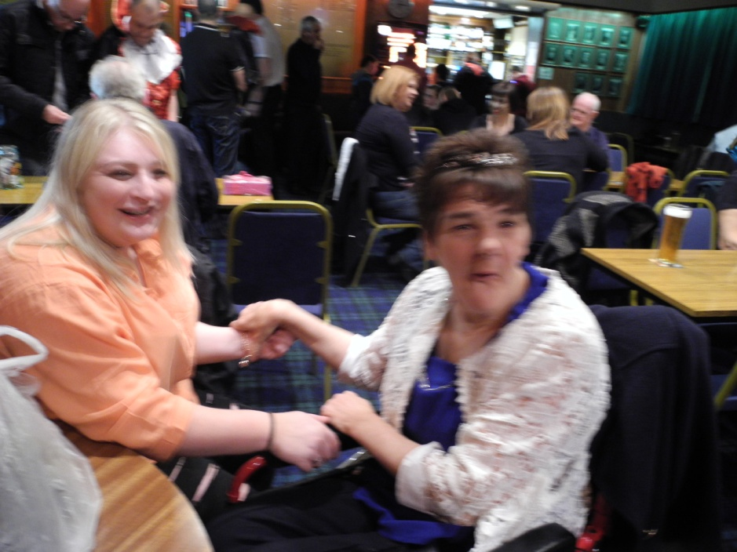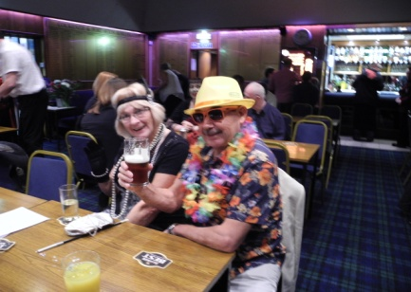

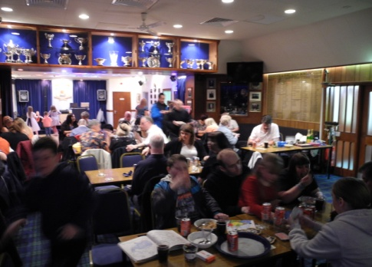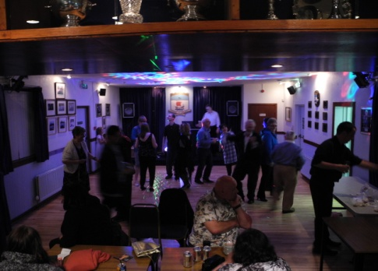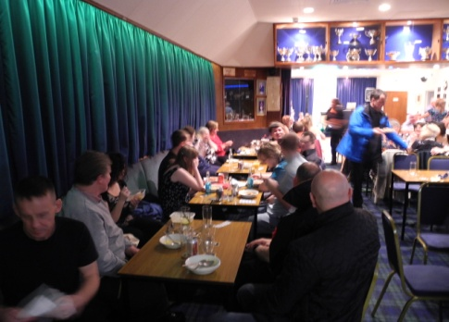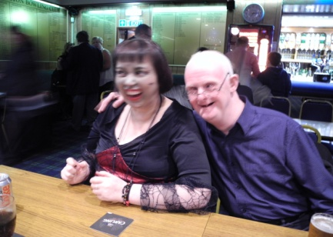

**Future’s Fair**

The Futures Fair is an information event for young people with additional support needs and their families so they can plan for their future together. East Lothian Council had a few stalls and displays from Tynebank, Fisherrow and Port Seton with staff on hand to answer any questions. Here are some pictures from the event held on November 6th at Musselburgh Brunton Hall.

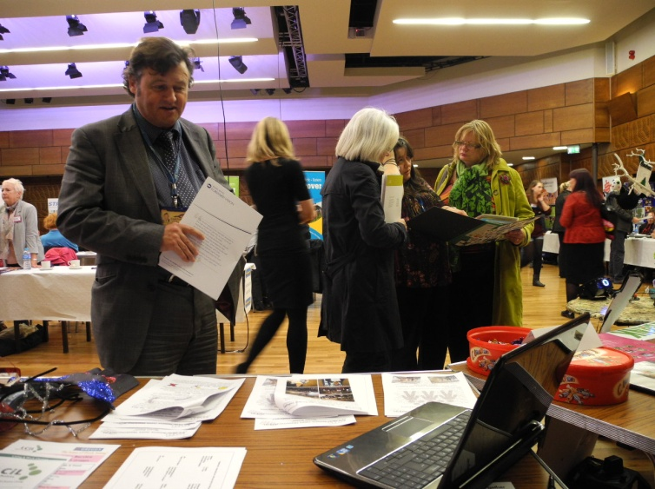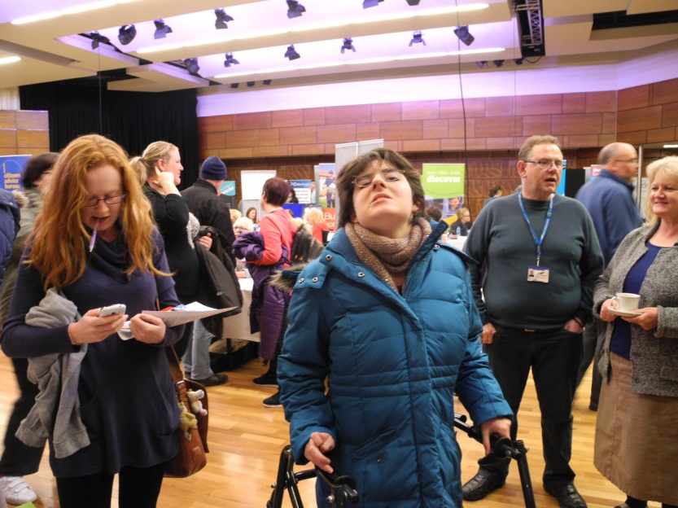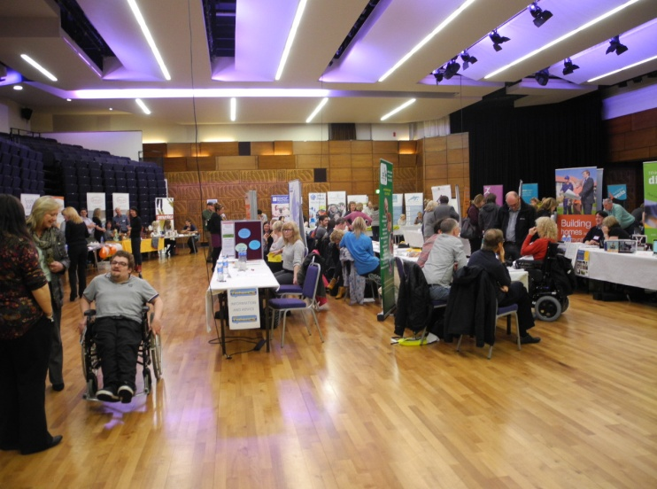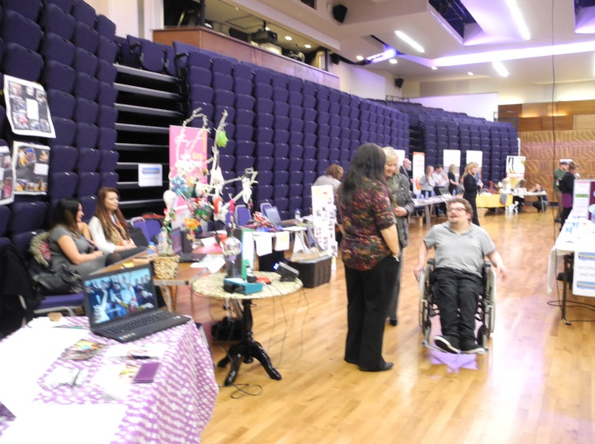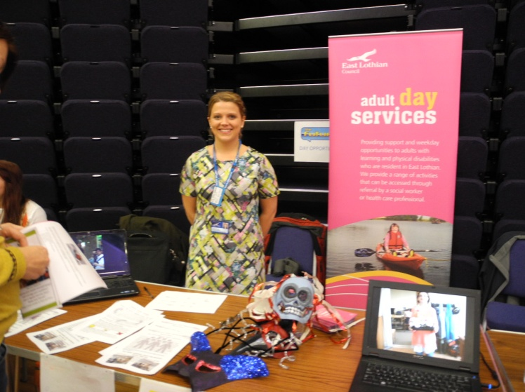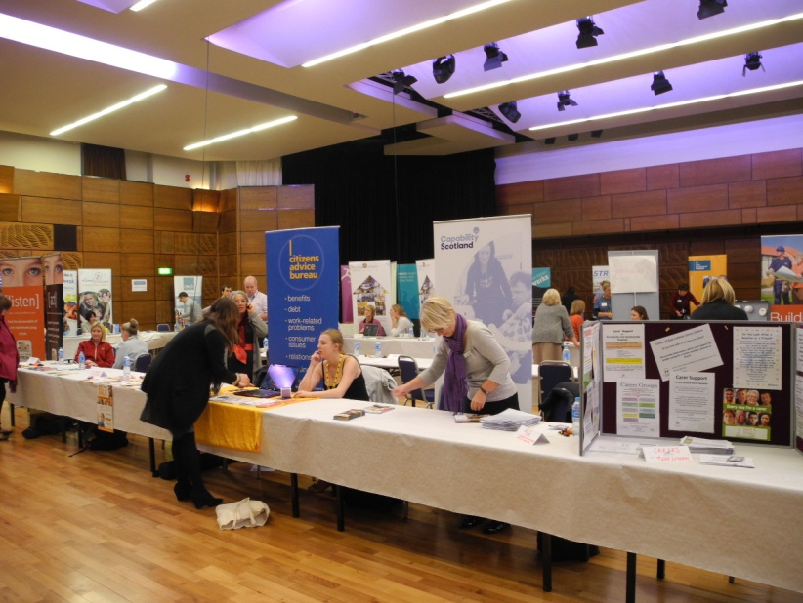**** **New PSRC Group Activity **

* **Boxercise -**

I don’t know if this Boxercise Group has been on before but it certainly rings some bells for me. It looks like all good sweaty fun, with a bit of exercise, and the chance to lamp your favourite care worker. What’s not to like? Unfortunately, I’ve never managed to land a glove on anybody – YET!

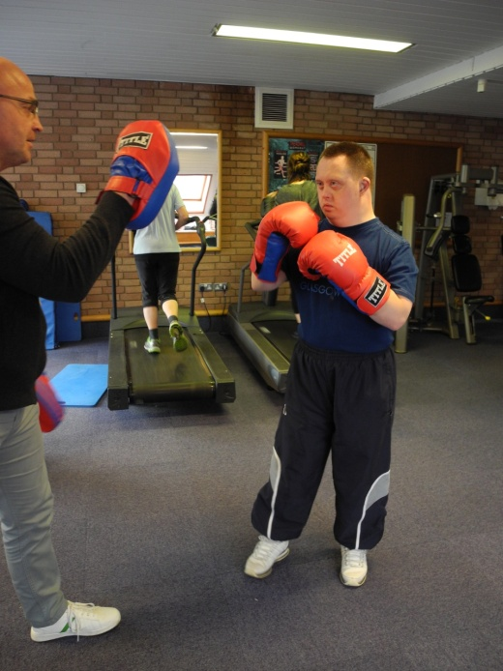

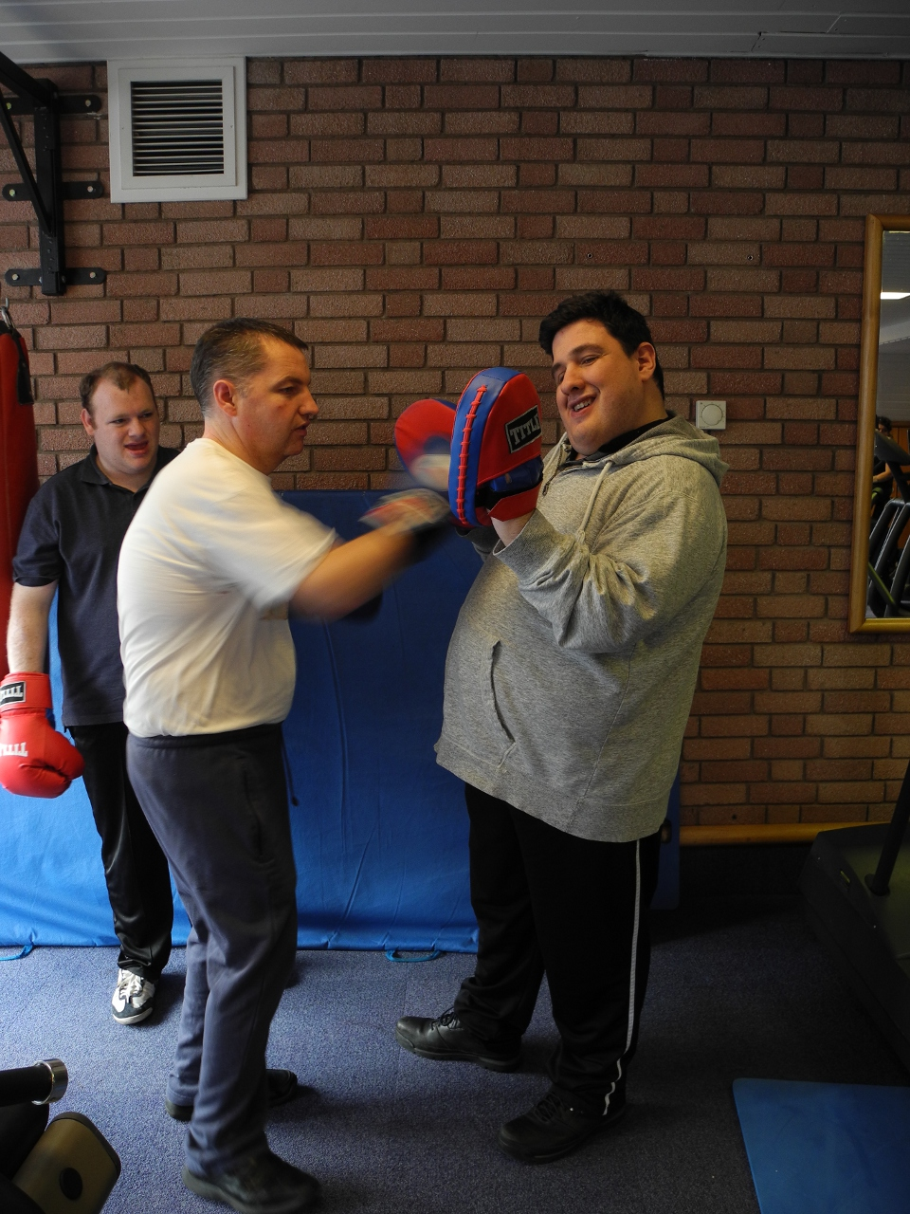

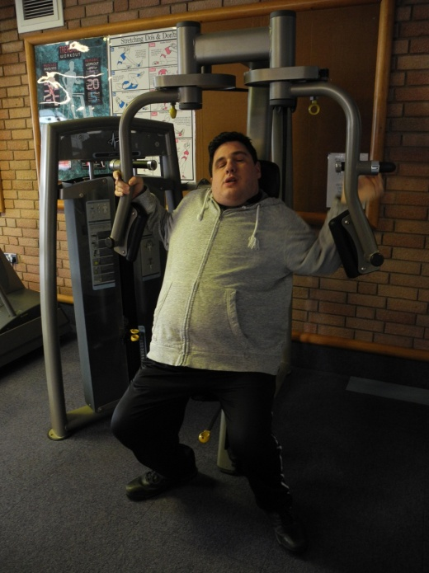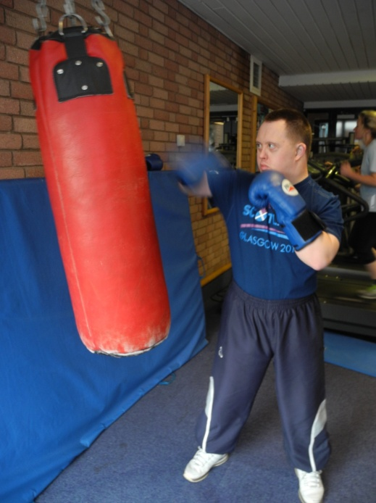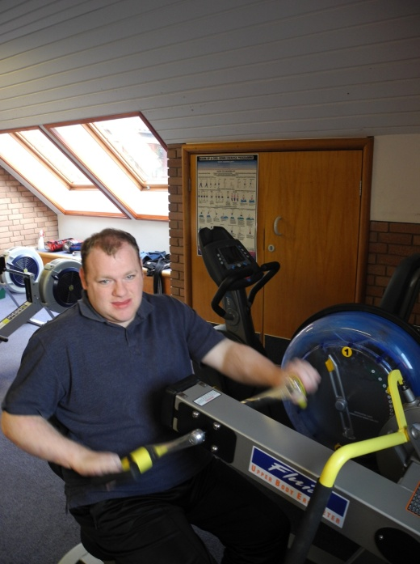

**INFORMATION**

**Christmas Lunch Party - PSRC**

Could all staff, carers and service users please contact the centre if they would like to come to our Christmas Lunch Party. It’s on the 18th December 2014 in the cafe, 12:30 to 3:00. Starter, Turkey and Trimmings, plus Pud. Music by Eddie, bring your own dancing feet. £5:00 – It’s the best bargain ever!!!

**Fisherrow Hub Evening Drop-In Dates and Times**

An evening of fun, relaxation and social activities. Dates for Fisherrow Hub are:

* Thursday 8th and 22nd Jan 2015 6:00 to 8:30
* Thursday 12th and 26th Feb 2015 6:00 to 8:30

**Port Seton Resource Centre Web Site**

As ever information on recent and previous groups and activities can be found by using our web site.

Here is the URL: <http://psrc.org.uk/>

**Fixed Public Holidays:**

Wednesday 24th Dec 2014 – half day only - closed at 1:00.

Thursday 25th December 2014 to Friday 2nd January 2015 inc.

**Email communication:**

Anyone wishing to receive communication/information using email please contact Bruce or Mike using email info below. Thanks.

**Contact Details:**

Phone : 01875 818175

Email : [bsmith@eastlothian.gov.uk](mailto:bsmith@eastlothian.gov.uk)

Email : [mveitch@eastlothian.gov.uk](mailto:mveitch@eastlothian.gov.uk)