|  |  |  |
| --- | --- | --- |
|  | Headway  East Lothian  SC10  Newsletter  [www.headway-eastlothian](http://www.headway-eastlothian).org.uk |  |
| Issue 16/08 | Honorary President  Dr Alasdair Fitzgerald | August 2016 |



We are very pleased to let everyone know that we received a cheque to the value of £3908.40 from M&S staff at Fort Kinnaird which they donated after their year of fundraising for both Headway East Lothian and Edinburgh Headway; thanks to all who helped in the Bag packing days; family, friends and volunteers and especially to the ladies from Thompsons Solicitors who helped us out!

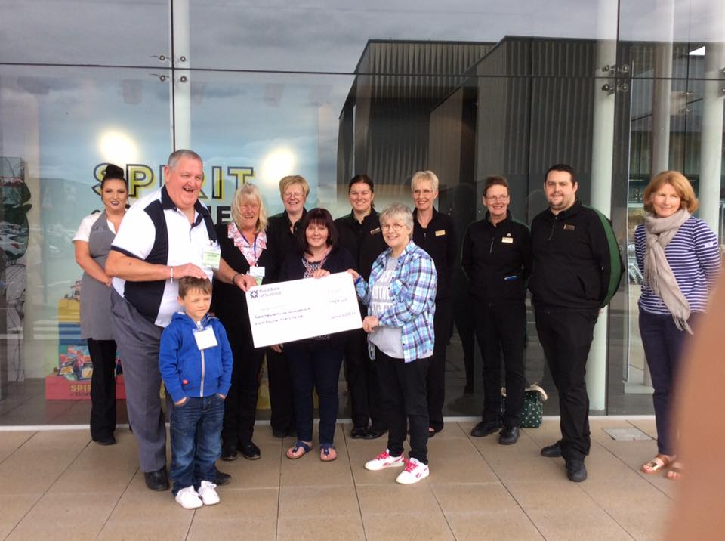

|  |
| --- |
| awards-for-all-logoLloyds TSB Foundation |

Noticeboard

|  |  |
| --- | --- |
|  | Carer meetings held on Mondays as required |
|  | Relaxation classes held on Mondays as required |
| meeting-room | Next Board Meeting  Wednesday 26th August  Haddington |
| NEXT  OUTING | Friday  30th August  ????? |

Golf Tournament

Brian Burns Memorial Trophy



Winterfield Golf Club, Dunbar

Saturday 20th August

If you would like to donate a raffle prize please contact Joyce Cattanach, David or Kate Dickson at any of the meetings.



Thanks to the team from Ross High School; Kirsten, Sarah and Fay for all their hard work in producing an excellent presentation about Headway East Lothian and living with an acquired brain injury. We received a cheque to the value of £3000 from YPI Scotland and hope to have the girls along to our Awards evening to show them how much we appreciate their efforts. The girls made this video as part of their presentation, please have a look,

<https://www.youtube.com/watch?v=0zn9B5QV8UA>

Carers Meetings



If you are a carer of someone with an acquired brain injury; friend, family member or loved one, and would like to meet fellow carers then please join us for coffee, tea and a blether in the cafe area of MECLC

Celebrate Success Awards



ll welcome to come along to the Doughty Centre, Herdmanflat Hospital, Aberlady Road, Haddington, Wednesday 7th September 7.00pm onwards!

There will be light refreshments on offer, a chance to mingle and chat and of course the announcement of our very own awards for those who have achieved goals small or large; furthered the work of Headway in the community and helped us during the year month at

This month at Headway

|  |  |  |  |
| --- | --- | --- | --- |
| 1 | Mon | Musselburgh | Chat & dominoes |
| 2 | Tues |  |  |
| 3 | Wed | Haddington | Members night – you choose |
| 4 | Thu | Dunbar | Games galore – Joyce |
| 5 | Fri |  |  |
| 6 | Sat |  |  |
| 7 | Sun |  |  |
| 8 | Mon | Musselburgh | Chat & dominoes |
| 9 | Tues |  |  |
| 10 | Wed | Haddington | Summer Quiz night |
| 11 | Thu | Dunbar | Conversation Cafe - Joyce |
| 12 | Fri |  |  |
| 13 | Sat |  |  |
| 14 | Sun |  |  |
| 15 | Mon | Musselburgh | Carers Meeting in Cafe 2.00pm |
| 16 | Tues |  |  |
| 17 | Wed | Haddington |  |
| 18 | Thu | Dunbar | Summer Quiz – Joyce |
| 19 | Fri |  |  |
| 20 | Sat | Dunbar | Golf Tournament |
| 21 | Sun |  |  |
| 22 | Mon | Musselburgh | Stone painting |
| 23 | Tues |  |  |
| 24 | Wed | Haddington | Stone painting |
| 25 | Thu | Dunbar | Stone painting - Joyce |
| 26 | Fri | ?????? | Mystery Tour |
| 27 | Sat |  |  |
| 28 | Sun |  |  |
| 29 | Mon | Musselburgh | Chat & dominoes |
| 30 | Tues |  |  |
| 31 | Wed | Haddington | Board meeting |

Meetings

‘**Monday T**he Musselburgh East Community Association (MECA) building,

Wallyford Road, just up from Levenhall roundabout 1pm - 4pm. A chance to meet over a cup of coffee. There is a café where lunch or a snack can be purchased.

**Wednesday T**he Doughty Centre Herdmanflat Hospital Aberlady Road Haddington at 6.30pm Wednesday evenings with a speaker etc. The meeting finishes at 8.30pm.We are not connected to the hospital.

Th**ursday** we meet at Hallhill Healthy Living Centre, Dunbar on a Thursday

12 noon- 2pm for those who live in Dunbar and surrounding area.

Contact Us

|  |  |
| --- | --- |
| Jim Maryniak  Convener | 07920 195743  [jimmaryniak@hotmail.com](mailto:jimmaryniak@hotmail.com) |
| Richard Fairbairn  Treasurer | 077604 95851  [james.fairbairn123@btinternet.com](mailto:james.fairbairn123@btinternet.com) |
|  |  |
|  |  |
| Development Officer  Joyce Cattanach | 07895 193974  [headwayeastlothian@live.co.uk](mailto:headwayeastlothian@live.co.uk) |

Joyce is also available at The Bleachingfield Centre, Countess Crescent, Dunbar, EH42 1DX, by appointment, Mondays, Tuesdays & Wednesdays and for outreach at other times.

Items for the newsletter to Robert Dalrymple r[obert.dalrymple202@](mailto:obert.dalrymple202@)btinternet.com Tel 01620 844020



Improving life after brain injury Charity No **SC035535**

Next Board

Meeting



1.30 pm MECA

in January tbc