|  |  |  |
| --- | --- | --- |
|  | Headway  East Lothian  SC10  Newsletter  [www.headway-eastlothian.org.uk](http://www.headway-eastlothian.org.uk/) |  |
| Issue 17/02 |  | February 2017 |

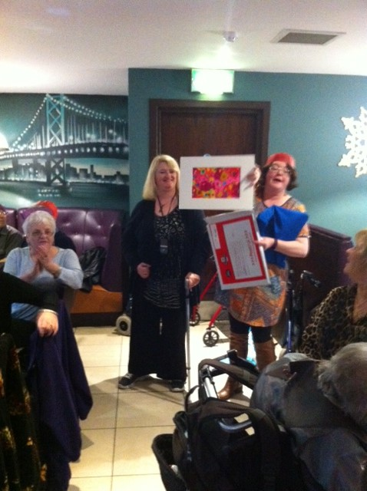

Digby Brown Christmas Card & Calendar competition

As you know, Nina-Jane Rae's entry was selected as one of this year's winners!

She is pictured here showing her winning entry to those at the Christmas Lunch at The Quay in Mussselburgh and receiving a certificate from Joyce.

|  |
| --- |
| Lloyds TSB Foundation  awards-for-all-logo |

Noticeboard

|  |  |
| --- | --- |
|  | Carer meetings held on Mondays as required |
|  | Relaxation classes held on Mondays as required |
| E:\2009-03-27, pdrc eyemouth\pdrc eyemouth 002.jpg | Next Outing  Dunbar Garden Centre  Friday 24th February |
| meeting-room | Next Board Meeting  Wednesday 1st March  Haddington |

Outings & Events 2017

January - 25th – Wednesday - Burns Supper

27th – Friday - Fort Kinnaird (shopping/cinema/lunch)

February - 24th – Friday - Dunbar Garden Centre

March - 31st – Friday - Scottish Parliament Tour

April - 17th - Easter Monday Holiday

              28th – Friday - 10 Pin Bowling

May - 30th - Tuesday - Bo'ness Steam Railway

June - 30th – Friday - Mystery Tour

July - 28th – Friday - BBQ

August - 20th – Sunday – Alternative 3 Peaks & Sponsored Walk

September - 18th - Holiday Monday

                      29th – Friday - Newtongrange Mining Museum

October – 13th – Friday - Christmas Shopping

November - 24th – Friday - Outing to be confirmed

December - 8th or 11th – Friday or Monday - Christmas Lunch

18th – Monday - Christmas Party & Raffle - Musselburgh

                      20th – Wednesday - Christmas Party - Haddington

                      21st – Thursday - Christmas Party - Dunbar

Our trip to Rwanda

About 4 months ago a few family and friends went out to Rwanda to help in a primary school and they are coming along to Haddington on the evening of 22nd February Wednesday to tell us about their experiences.

The population is [young](https://en.wikipedia.org/wiki/Youth_in_Rwanda) and predominantly rural, with a density among the highest in Africa. Rwandans are drawn from just one cultural and linguistic group, the [Banyarwanda](https://en.wikipedia.org/wiki/Banyarwanda" \o "Banyarwanda), although within this group there are three subgroups: the [Hutu](https://en.wikipedia.org/wiki/Hutu), [Tutsi](https://en.wikipedia.org/wiki/Tutsi) and [Twa](https://en.wikipedia.org/wiki/Great_Lakes_Twa" \o "Great Lakes Twa).

The Twa are a forest-dwelling [pygmy people](https://en.wikipedia.org/wiki/Pygmy_peoples) descended from Rwanda's earliest inhabitants. Scholars disagree on the origins of and differences between the Hutu and Tutsi; some believe differences are derived from former social [castes](https://en.wikipedia.org/wiki/Caste) within a single people, while others believe the Hutu and Tutsi arrived in the country separately and from different locations.

Christianity is the largest religion in the country; the principal language is [Kinyarwanda](https://en.wikipedia.org/wiki/Kinyarwanda), spoken by most Rwandans, with English and French serving as official languages.

Rwanda’s economy suffered heavily during the 1994 Rwandan Genocide, but has since strengthened. The economy is based mostly on subsistence agriculture. Coffee and tea are the major cash crops for export. [Tourism](https://en.wikipedia.org/wiki/Tourism_in_Rwanda) is a fast-growing sector and is now the country's leading foreign exchange earner.

SAVE THE DATES

Head Injury Information Days

These events are FREE

**WEDNESDAY 10TH MAY 2017**

# WEST CENTRAL SCOTLAND HIID

## DoubleTree by Hilton Hotel,

36 Cambridge Street, Glasgow G2 3HN

**WEDNESDAY 17TH MAY 2017**

# EDINBURGH AND LOTHIANS HIID

## Hilton Edinburgh Grosvenor,

5-21 Grosvenor Street, Edinburgh EH12 5EF

This month at Headway

|  |  |  |  |
| --- | --- | --- | --- |
| 1 | Wed | Haddington | You choose! |
| 2 | Thu | Dunbar | You choose! |
| 3 | Fri |  |  |
| 4 | Sat |  |  |
| 5 | Sun |  |  |
| 6 | Mon | Musselburgh | Quizzes, dominoes & chat |
| 7 | Tues |  |  |
| 8 | Wed | Haddington | Newspaper review |
| 9 | Thu | Dunbar | Newspaper review |
| 10 | Fri |  |  |
| 11 | Sat |  |  |
| 12 | Sun |  |  |
| 13 | Mon | Musselburgh | Quizzes, dominoes & chat |
| 14 | Tues |  |  |
| 15 | Wed | Haddington |  |
| 16 | Thu | Dunbar | February Fling |
| 17 | Fri |  |  |
| 18 | Sat |  |  |
| 19 | Sun | Haddington |  |
| 20 | Mon | Musselburgh | Carers in the Café |
| 21 | Tues |  |  |
| 22 | Wed | Haddington | Our trip to Rhwanda |
| 23 | Thu | Dunbar | Music appreciation |
| 24 | Fri | Outing | Dunbar Garden centre |
| 25 | Sat |  |  |
| 26 | Sun | Haddington |  |
| 27 | Mon | Musselburgh | Quizzes, dominoes & chat |
| 28 | Tues |  |  |

Meetings

**Monday T**he Musselburgh East Community Association (MECA) building,

Wallyford Road, just up from Levenhall roundabout 1pm - 4pm. A chance to meet over a cup of coffee. There is a café where lunch or a snack can be purchased.

**Wednesday T**he Doughty Centre Herdmanflat Hospital Aberlady Road Haddington at 6.30pm Wednesday evenings with a speaker etc. The meeting finishes at 8.30pm. We are not connected to the hospital.

**Thursday** we meet at Hallhill Healthy Living Centre, Dunbar on a Thursday

12 noon- 2pm for those who live in Dunbar and surrounding area.

Contact Us

|  |  |
| --- | --- |
| Jim Maryniak  Convener | 07920 195743  [jimmaryniak@hotmail.com](mailto:jimmaryniak@hotmail.com) |
| Richard Fairbairn  Treasurer | 077604 95851  [james.fairbairn123@btinternet.com](mailto:james.fairbairn123@btinternet.com) |
|  |  |
|  |  |
| Development Officer  Joyce Cattanach | 07895 193974  [headwayeastlothian@live.co.uk](mailto:headwayeastlothian@live.co.uk) |

Joyce is also available at The Bleachingfield Centre, Countess Crescent, Dunbar, EH42 1DX, by appointment, Mondays, Tuesdays & Wednesdays and for outreach at other times.

Items for the newsletter to Robert Dalrymple [robert.dalrymple202@btinternet.com](mailto:robert.dalrymple202@btinternet.com?subject=Newsletter%20Item) Tel 01620 844020



Improving life after brain injury Charity No **SC035535**

Next Board

Meeting



1.30 pm MECA

in January tbc